# C# Code Header Designer 2.0 – User Guide

The C# Code Header Designer (the Designer) gives developers the ability to design code headers, save the headers for future use, and apply headers to existing source trees.

**NOTE: The Visual Studio solution/project integration is for Visual Studio 2008 only at this time.**

## Getting Started

The Designer provides the following features to enable code header design, storage, and application:

1. A simple editor that emulates the look of a source editor
2. A means to add fields to a header, which are replaced by values specified by the user when the header is applied
3. Auto fields, which are fields whose values are automatically inserted into the header by the system
4. Specify a Visual Studio 2008 solution or project, which is used to determine which source files to include in header application
5. Maintain a log of actions taken on the source files

After installation, click **Start\Program Files\Colby Africa\CSharp Header Designer** to begin.

*Continued on the next page.*

## The Main FORM

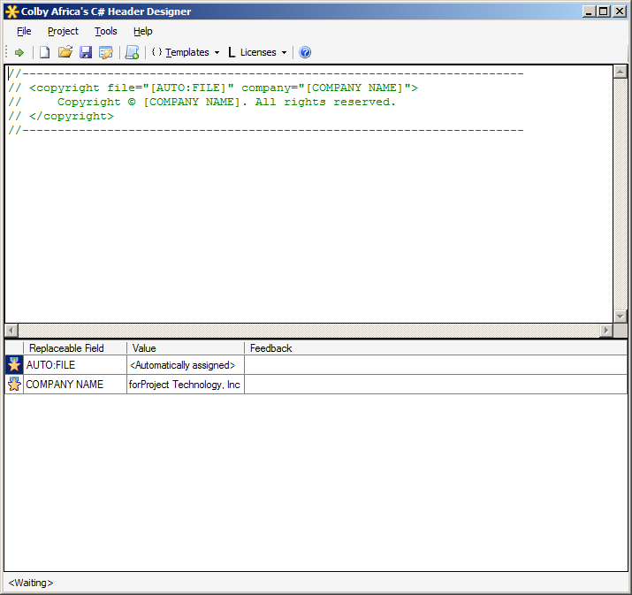

Header input area

Menu and Toolbar

User and System “Auto” fields

## Main Menu and Toolbar

Unlike previous versions, version 2.0 sports a menu and toolbar.

### Main Menu

The main menu has the following top-level menu items and submenus:

1. File
   1. New – Create a new header project
   2. Open—Open an existing header project
   3. Save – Save the currently open header project
   4. Exit – Exit the application
2. Project
   1. Add Files – Add source files to the currently opened header project
   2. Apply Headers – Apply the header to all source files in the currently opened header project
   3. Properties—Opens the project properties dialog for the currently opened header project
3. Tools
   1. View Log – Opens the Log Viewer

#### Toolbar



|  |  |
| --- | --- |
| Apply headers | Apply Template |
| New Project | Insert License |
| Open Project | Open user guide |
| Save Project |  |
| Project Properties |  |
| Add Files |  |

## Project Properties Form

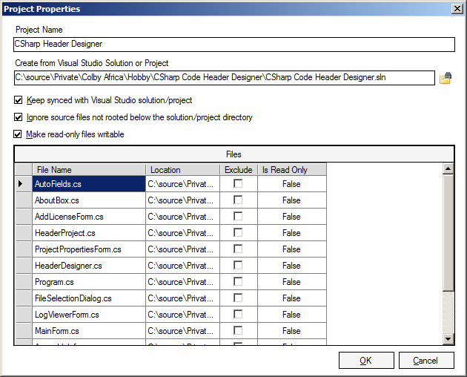

New to this version is the ability to specify a Visual Studio 2008 project or solution as the starting point for adding source files to the project. You have the option of syncing the header project to the Visual Studio project or solution each time the header project is opened. You may also ignore source files that are rooted below the root of the solution or project. Checking the Exclude checkbox in the grid for a particular file will exclude the file from header application.

Finally, you can force the header application to make read-only files writable.

Clicking any cell in the last row of the grid will open the Select Files Dialog.

## The Select Files Dialog

The purpose of the Dialog is for you to specify which files should have the header applied.

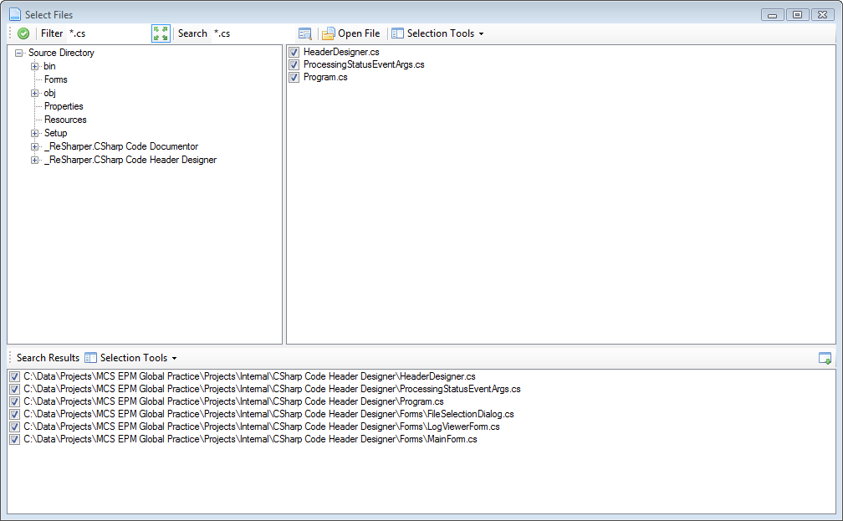

Files List

Primary Action Buttons

Directory Tree

Search Results

The Select Files Toolbar provides access to several features which allow you to locate the specific file you need or optionally select batches of files:



|  |  |  |  |
| --- | --- | --- | --- |
|  |  |  |  |
| When done selecting files, click to return to Main Dialog. | By default, only files ending with “.cs” are included. The filter can be modified.  The  button automatically excludes designer files and other codegen files. | Search for a specific file or use wildcards to search for many files. | Open the selected file and use the selection tools to select or unselect batches of files. |

## Header Templates and Fields

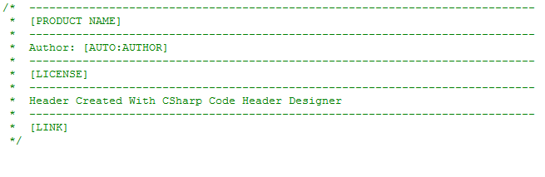The header template is the text in the header editor, as shown to the right. Keep in mind that the header is inserted, minus the fields which are enclosed by brackets ([FIELD_NAME]), as is. The “//” or “/* */” comment styles are both supported.

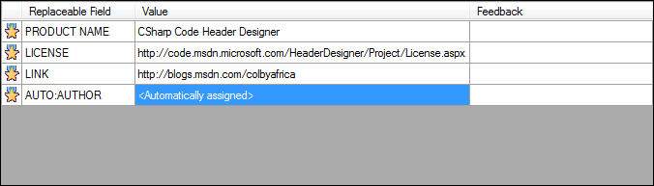The Field Table, displayed below left, is where the user inputs the values for the fields. Auto Fields are fields that are populated for you by the system when the header is applied. The supported Auto Fields are:

[AUTO:AUTHOR], which inserts the machine name and user name of the file;

[AUTO:FILE], which inserts the name of the file.

[AUTO:SOLUTION], which inserts the name of the solution

[AUTO:PROJECT], which inserts the name of the project

[AUTO:NAMESPACE], which inserts the namespace

[AUTO:CREATION_DATE], which inserts the creation date of the file

[AUTO:MODIFICATION_DATE], which inserts the modification date of the file

[AUTO:SUMMARY], which inserts the summary of the first class/struct/enum/interface in the file

[AUTO:INHERIT], which inserts the mother class of the class/struct/enum in the file

[AUTO:IMPLEMENT], which inserts the interfaces implemented by the class/interface in the file

[AUTO:CURRENT_DATE], which inserts the current date

[AUTO:CURRENT_YEAR], which inserts the current year

Once complete, the Tools\View Log menu item is enabled, allowing you to view a log of the actions taken on each file:

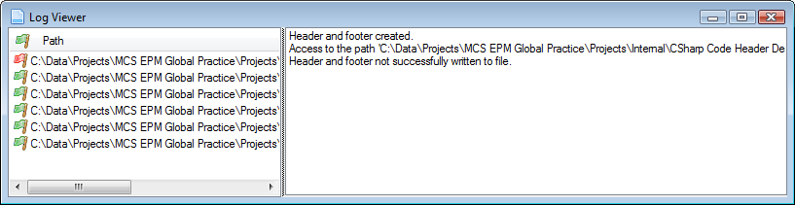

Note the red flag on the first item, which indicates an error.